Task 4 – Network IDS using Suricata
Internship: CodeAlpha
Name: Zain Asad
﻿

2. Objective
The primary goals of this task include:
Setting up a network-based Intrusion Detection System (IDS) to detect malicious traffic using Suricata 7.0.10.
Verifying alerts generated for ICMP (Internet Control Message Protocol) traffic.
﻿
﻿

3. Custom Rules Configuration
To detect ICMP traffic, a custom rule was defined in the local rules file.
File Path: /var/lib/suricata/rules/local.rules
Rule Code: alert icmp any any -> any any (msg:"ICMP Ping Detected"; sid:1000001; rev:1;)
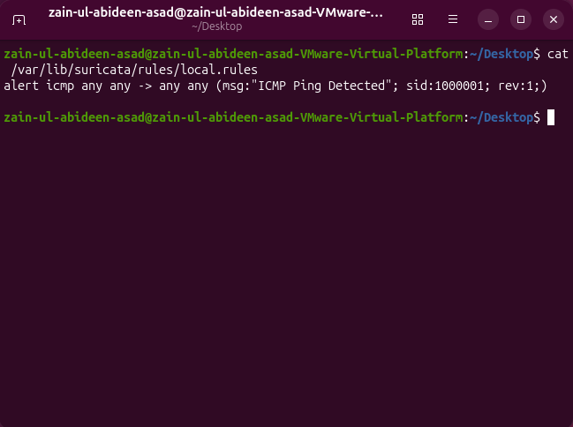
﻿

4. Alerts – Terminal Execution
To initiate Suricata and monitor the specific network interface (ens33), the following command was executed in the terminal:
sudo suricata -c /etc/suricata/suricata.yaml -i ens33 --af-packet -v
﻿

5. Alerts – Log File Analysis
Terminal logs were captured and stored in the default Suricata log directory. The log file was checked using the following command:
cat /var/log/suricata/fast.log The output confirms the detection of traffic with the message: "ICMP Ping Detected".
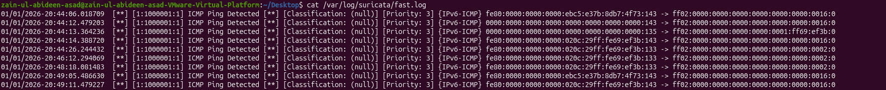﻿

6. Conclusion
The task was successfully completed with the following outcomes:
The custom ICMP rule was successfully verified.
The IDS effectively detected live network traffic.
Logs were accurately captured for further analysis.
The environment is now ready for internship submission.
﻿

